LifeWay Visitors
LifeWay Christian Resources wants to welcome you and make locating and accessing our new building as easy as possible. This is not our mailing address, but for best results please use this address for GPS directions: 1100 Jo Johnston Ave., Nashville, TN.
PARKING (note: clearance is 8’ 2”)
- The visitor parking garage can be accessed from the driveway near the intersection of LifeWay Plaza and George L. Davis. Street parking is also available in front of the building along LifeWay Plaza.
- Enter the parking garage along LifeWay Plaza close to the freeway overpass. On one corner of the building there is a sign stating, “Visitor Parking” and on the other side of the building painted on the brick is “LifeWay Biblical Solutions for Life.” Pass our loading dock area until you see closed garage doors with “Visitors” above the door. The garage doors will open automatically when a vehicle approaches.
- The garage door clearance is 8’ 2”, but inside toward the entrance to the building there is a bar reducing the clearance to 7’. Be sure to park close to the garage doors if your vehicle is above 7’.
- Proceed to the southeast corner of visitor parking where a large “1” is painted on a burgundy wall. Enter our grand foyer during LifeWay Store hours (9:00 a.m. to 7:00 p.m. - closed Sundays). Outside of store hours, guests should proceed to the front door entrance by walking out of the parking garage along LifeWay Plaza street.
- Entrance to the grand foyer from the street is at the corner of LifeWay Plaza and 11th Avenue.
- See map below:
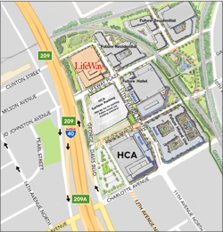
INSIDE THE BUILDING
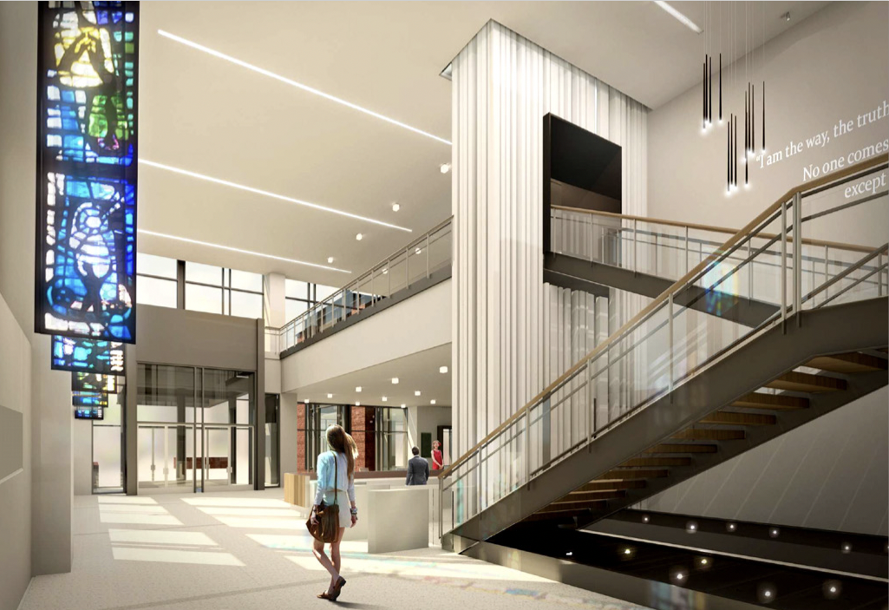

- Entrance doors are set up for handicapped access. There is a square metal plate to press to activate them. They can, of course, be opened manually, but they are heavier to open than regular doors.
- When entering the grand foyer from the parking garage, the reception desk is located to your right immediately after the stairs.
- LifeWay Corporate guests are required to check in at the reception desk. This is not required to access the LifeWay Bookstore.
- Guests can check in between 6 a.m. and 7 p.m. Corporate guests will register and receive a corporate guest badge which must be worn while in the building.
- A LifeWay employee will be called to the grand foyer to escort guests to their meeting location and take them down to the grand foyer when they leave.
- Guests need to check out and return their guest badges.

