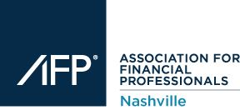

December 12, 2019

Dear Members and Guests:
Thank you for your continued support of the Association for Financial Professionals--Nashville and for joining us today for the 37th Annual Seminar. We hope that you find the information shared today from industry thought leaders to be timely, relevant and beneficial to your professional career.
AFP-Nashville’s goals are to provide:
- Impactful meetings with timely topics that help you successfully navigate the challenges and opportunities faced by you and your organization.
- Networking opportunities to share ideas and best practices with fellow members.
- Continuing Education credits (CTP and CPE), up to 15 credits per year
Here are a few membership statistics
- 86 Active Members; up from 71 Members at this time last year
- 45 CTP’s and 14 CPA’s
- 44 Corporate Practitioners
- 42 Financial Service Providers
AFP-Nashville encourages board involvement among it’s members. If you have an interest in serving on the board, please let one of the board members know.
We hope you enjoy today’s presentations and we welcome any future topic or speaker suggestions. We especially want to thank our Platinum Sponsor, FIS Global, as well as our other sponsors who have contributed to the success of this seminar.
Sincerely,

Sue K. Veith, CCM
President
Association for Financial Professionals-Nashville

